WORSHIP
Sixteenth Sunday After Pentecost September 25, 2022

WELCOME and ANNOUNCEMENTS

Prelude

CALL TO WORSHIP
Holy, holy, holy is the Lord of hosts.
Heaven and earth are filled with the glory of God.
Come, let us worship the God of glory.

OPENING PRAYER (unison)
O Lord our God, we give you thanks for the grace that is at work in us
through the gift of our baptism—the sign of your threefold name,
the communion of your faithful people, the promise of your glorious realm. By the power of your Holy Spirit, poured out upon us in baptism, let your grace and peace grow in us, until we gather at your heavenly throne to give you thanks and praise forever; through Jesus Christ our Lord. Amen.

*HYMN: God of Grace and God of Glory Hymnal 420

CALL TO CONFESSION (liturgist)
The triune God mercifully and graciously invites us into a relationship of wholeness. In humility and truth, let us confess the sin that keeps us from the life God intends.

*PRAYER OF CONFESSION (unison)
Holy God, Father, Son, and Holy Spirit, Mother, Lover, and Friend, one God in three persons, mutual and whole, we confess our relationships are not that way. We have been too selfish; or we have given too much; or we have accepted too little. Our sin drives us away from one another and from you. Forgive us and restore us. Draw us close that we may know life in all of its fullness. Amen.

*ASSURANCE OF PARDON (liturgist)
God’s love is poured out through the Holy Spirit. This is love from God’s own heart, love that cleanses and renews. This is good news!
In Jesus Christ we are redeemed.

*GLORIA PATRI Hymnal 579

CHILDRENS’ SERMON

PRAYER FOR ILLUMINATION (unison)
Holy, Holy, Holy One, guide us by the Spirit of truth to hear the Word of life you speak, and to give all glory, honor, and praise to your threefold name; through Jesus Christ our Lord. Amen.

FIRST READING: Amos 6.1a, 4-7
SECOND READING: Luke 16.19-31

SERMON: If I Were a Rich Man Rev. Camille Josey

*HYMN Rejoice Ye Pure in Heart Hymnal 145

JOYS AND CONCERNS

PRAYERS OF THE PEOPLE
THE LORD’S PRAYER: (unison)
Our Father, who art in heaven, hallowed be thy name. Thy kingdom come, thy will be done, on earth as it is in heaven. Give us this day our daily bread; and forgive us our debts as we forgive our debtors. Lead us not into temptation, but deliver us from evil, for thine is the kingdom, and the power, and the glory, forever and ever. Amen.

AFFIRMATION OF FAITH (unison) Barmen Declaration 8.11, 12, 14, 15,17
“Jesus Christ, as he is attested for us in Holy Scripture, is the one Word of God which we have to hear and which we have to trust and obey in life and in death…We reject the false doctrine, as though the church could and would have to acknowledge as a source of its proclamation, apart from and besides this one Word of God, still other events and powers, figures and truths, as God’s revelation…As Jesus Christ is God’s assurance of the forgiveness of all our sins, so in the same way and with the same seriousness is he also God’s mighty claim upon our whole life. Through him befalls us a joyful deliverance from the godless fetters of this world for a free, grateful service to his creatures…We reject the false doctrine, as though there were areas of our life in which we would not belong to Jesus Christ, but to other lords—areas in which we would not need justification and sanctification through him…The Christian Church is the congregation of the brethren in which Jesus Christ acts presently as the Lord in Word and Sacrament through the Holy Spirit. As the church of pardoned sinners, it has to testify in the midst of a sinful world, with its faith as with its obedience, with its message as with its order, that it is solely his property, and that it lives and wants to live solely from his comfort and from his direction in the expectation of his appearance. We reject the false doctrine, as though the church were permitted to abandon the form of its message and order to its own pleasure or to changes in prevailing ideological and political convictions.”

INVITATION TO GIVE

Special Music

*DOXOLOGY

*PRAYER OF DEDICATION

*HYMN O Worship the King Hymnal 476

*BENEDICTION

*AMEN (sung)

Postlude

September 18, 2022 Attendance in person: 13 Virtual: 10
Offering (General): $1,920.00
Offering (designated): 0.00
Offering (Total): $. 1,920.00
Average General Giving per Week $ 1,049.31

Giving YTD $42,490.79

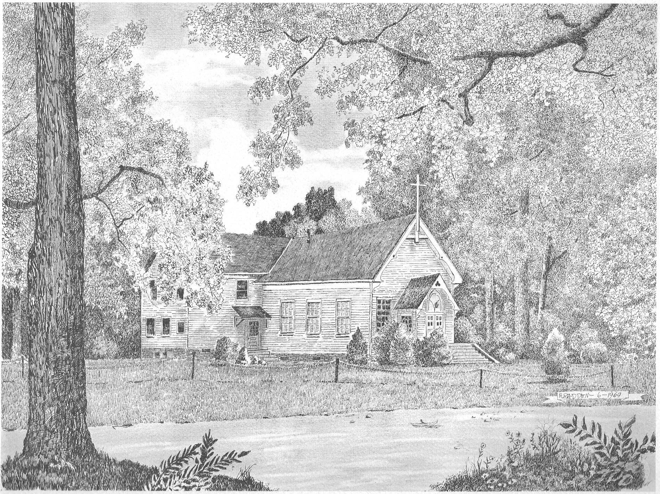

Silver Creek
Presbyterian Church
6 Old Rockmart Road
Silver Creek, GA 30173
706-234-6862
www.silvercreekpcusa.org

Rev. Camille Josey
Sixteenth Sunday After Pentecost September 25, 2022

