WORSHIP
Epiphany, January 7, 2024

Chiming of the Hour

WELCOME and ANNOUNCEMENTS

Prelude and Lighting of the Candles

*CALL TO WORSHIP
This little light of mine
I’m going to let it shine.
This little light of the world
has overcome the darkness.
We have followed the light to this place,
and the glory of God’s presence is among us!
Let us worship God!

*OPENING PRAYER (unison)
Great God, Magi from the east were looking for Jesus. Herod was looking for Jesus. We are looking for Jesus, and we are overcome with amazement that you became one of us in the Christ-child.
Teach us what it means to surrender what we have, to fall on our knees, and to worship you. As we move from this place to our diverse homes, help us to carry our adoration with us, that we might not be tempted to reject the love that brought us here.
In Jesus’ name, we pray. Amen.

*HYMN Jesus Shall Reign Where’er the Sun Hymnal 423

*CALL TO CONFESSION
Like a great light in a land of deep darkness, the mercy of the Lord shines upon us. Trusting in God’s grace, let us confess our sins before God.

PRAYER OF CONFESSION (unison)
God of wonder, God of night, you are holy light in dark places;
you are holy darkness when all is too bright. Forgive us, O God, when we turn away from your light: when we follow our own ambitions instead of your call, when we respond to your presence with fear rather than joy. Forgive us, O God, when we do not comprehend the depth of your Christmas love, the meaning of your powerful story, or the call you place on each of our lives.
Forgive us, O God, and by your forgiveness, empower us to follow the star once more. Amen

*ASSURANCE OF PARDON
Hear the promise of the Lord: See, your salvation has come! You are a holy people, redeemed by God, sought out, not forsaken. In the name of Jesus Christ, we are forgiven!
Thanks be to God!

*GLORIA PATRI Hymnal 579

CHILDREN’S SERMON

PRAYER FOR ILLUMINATION (unison)
Holy One, giver of all light, lift up our hearts and minds to Christ,
the morning star that never fades. By the light of your Holy Spirit
reveal to us your saving Word and lead us to offer our lives to you
in service and in love; through Jesus Christ our Lord. Amen.

FIRST SCRIPTURE READING: Isaiah 60.1-6
SECOND SCRIPTURE READING: Matthew 2.1-12

SERMON: Epiphany Rev. Camille Josey

*HYMN: Of the Father’s Love Begotten Hymnal 309

AFFIRMATION OF FAITH (Apostle’s Creed)
PRAYERS OF THE PEOPLE

SERVICE OF INSTALLATION of ELDERS JANET FARR AND TERRI OTT (see insert)

COMMUNION OF THE PEOPLE and INVITATION TO GIVE

Special Music

PRAYER AFTER COMMUNION

*DOXOLOGY

*HYMN Lo, How a Rose E’re Blooming Hymnal 48

*BENEDICTION

*AMEN (sung)

Postlude

________________________________________________________
December 31, 2023: Attendance: 9
Offering General: $ 900.00
Offering Designated: 0.00
Offering Total $ 900.00

Average Giving Per Week: $ 1,281.86
Average General Giving Per Week: $ 1,215.57

Total General Giving 2023: $64,092.00
Total Designated Giving 2019: $ 3.377.19

General Giving needed YTD to meet budget: $66,687.00

Liturgy Source: https://calltoworshipjournal.org/january-6-2024-epiphany-of-the-lord/

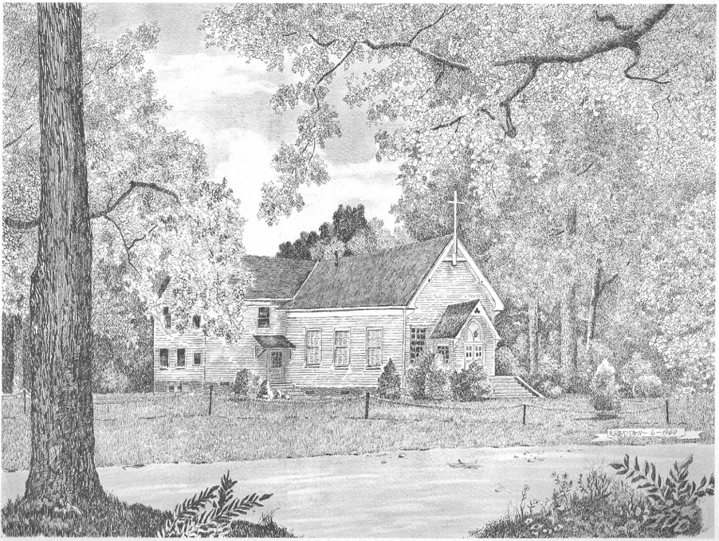

Silver Creek
Presbyterian Church
6 Old Rockmart Road
Silver Creek, GA 30173
706-234-6862
www.silvercreekpcusa.org

Rev. Camille Josey

Epiphany January 7, 2024

SERVICE OF ORDINATION AND INSTALLATION

STATEMENT ON ORDINATION AND INSTALLATION

CONSTITUTIONAL QUESTIONS

a. Do you trust in Jesus Christ your Savior, acknowledge him Lord of all and Head of the Church, and through him believe in one God, Father, Son, and Holy Spirit?

b. Do you accept the Scriptures of the Old and New Testaments to be, by the Holy Spirit, the unique and authoritative witness to Jesus Christ in the Church universal, and God’s Word to you?

c. Do you sincerely receive and adopt the essential tenets of the Reformed faith as expressed in the confessions of our church as authentic and reliable expositions of what Scripture leads us to believe and do, and will you be instructed and led by those confessions as you lead the people of God?

d. Will you fulfill your ministry in obedience to Jesus Christ, under the authority of Scripture, and be continually guided by our confessions?

e. Will you be governed by our church’s polity, and will you abide by its discipline? Will you be a friend among your colleagues in ministry, working with them, subject to the ordering of God’s Word and Spirit?

f. Will you in your own life seek to follow the Lord Jesus Christ, love your neighbors, and work for the reconciliation of the world?

g. Do you promise to further the peace, unity, and purity of the church?

h. Will you pray for and seek to serve the people with energy,
intelligence, imagination, and love?

- Will you be a faithful ruling elder, watching over the people, providing for their worship, nurture, and service? Will you share in government and discipline, serving in councils of the church, and in your ministry will you try to show the love and justice of Jesus Christ?

To the Congregation:

- Do we, the members of the church, accept Terri Ott and Janet Farr as ruling elders, chosen by God through the voice of this congregation to lead us in the way of Jesus Christ?
- Do we agree to pray for them, to encourage them, to respect their decisions, and to follow as they guide us, serving Jesus Christ, who alone is the Head of the Church?

DECLARATION OF INSTALLATION

CHARGE

COMMUNION OF THE PEOPLE

INVITATION TO THE TABLE

GREAT THANKSGIVING
The Lord be with you.
And also with you.
Lift up your hearts.
We lift them to the Lord.
Let us give thanks to the Lord our God.
It is right to give our thanks and praise.

Blessed are you, O Lord our God:
We look to you and we are radiant; we thrill and rejoice
as nations come to your light and leaders welcome your dawning.
You call us to arise, and shine, for your glory has risen upon us.
Therefore we praise you, joining the song of the universal church and the heavenly choir saying:
Holy, holy, holy Lord, God of power and might,
heaven and earth are full of your glory.
Hosanna in the highest.
Blessed is he who comes in the name of the Lord.
Hosanna in the highest.

Blessed is Jesus Christ, our Savior: With the ancient Magi, we come to pay him homage; we give him the treasures of our hearts, our lives.
As his star shines down upon us, we are overwhelmed with joy. The words of institution are included here. Remembering your goodness and grace, we offer ourselves to you with gratitude as we share this joyful feast.

Christ has died,
Christ is risen,
Christ will come again.

Pour out your Holy Spirit upon us and upon this bread and cup;
make us one in the body and blood of Jesus Christ our Lord.
By your Spirit, make us bold and confident in our faith, as you reveal to us the mystery of ages, your plan for the world— to bring all peoples to the knowledge of your grace in Jesus Christ. Through the Lord Jesus Christ, in the unity of the Spirit, we bless you, God of glory, now and forever.

LORD’S PRAYER

INVITATION TO GIVE
All things in heaven and on earth belong to God, who is coming in glory to reveal a new creation. Let us offer all that we have and all that we are to God as we are fed and nourished at our Lord’s Table where we are sustained by Christ’s pledge of undying love and continuing presence with us His people.

COMMUNION OF THE PEOPLE

DOXOLOGY

PRAYER AFTER COMMUNION
We give you thanks, O God, for the gifts of this table—
precious, prayerful, and poignant—like gold, frankincense, and myrrh. Lead us forth by your light to share the gifts of your grace
with all people everywhere, giving glory, honor, and praise
to Jesus Christ our Savior. Amen.

