WORSHIP
Third Sunday After Epiphany
January 22, 2023

WELCOME and ANNOUNCEMENTS

PRELUDE AND LIGHTING OF CANDLES

CALL TO WORSHIP
The Lord is my light and my salvation; whom shall I fear?
The Lord is the stronghold of my life; of whom shall I be afraid?
As we behold the beauty of God’s temple, we see God’s face.
God is our shelter and our shade. We will sing to the God of our salvation!

OPENING PRAYER
O Lord our God, we give you thanks for the faith, hope, and love you give to us through the blessing of our baptism—claiming us as your beloved children, calling us to the path of discipleship, revealing to us the light of your glory. By the power of your Holy Spirit, poured out upon us in baptism, help us to follow you with faith, to trust in you with hope, and to serve you with love; through Jesus Christ our Lord. Amen.

*HYMN: Praise, My Soul, the King of Heaven Hymnal 478

CALL TO CONFESSION (liturgist)
﻿Christ calls us to follow, knowing that we are human. Jesus knows
we are not perfect. He knows we will not always get it right. All he
asks is that we try, learn, and try again. Let us go to God, telling
how we have tried and failed, that God may teach us what we must
learn.

*PRAYER OF CONFESSION (unison)
﻿Christ, our Messiah, you call us to fish for people, but we are hesitant to leave our boats. We are afraid to let go of the things we hoard, believing they make us secure. We are afraid to put our trust in you,
afraid to follow, afraid we will fail. Forgive us. Transform our fear into faithfulness, and enable us to walk with you, that we may be part of your work in the world.

DECLARATION OF FORGIVENESS
Just as Jesus called the disciples, so Christ calls us. Forgiven of our sin
and freed to serve, let us answer Christ’s call. Christ calls us, forgives us, heals us, and teaches us.
Thanks be to God!

*GLORIA

CHILDREN’S SERMON

PRAYER FOR ILLUMINATION
Saving God, source of our calling, your Word is full of power and glory. Pour out your Holy Spirit upon us so that we may receive your grace and live as your beloved children; through Jesus Christ our Lord. Amen.

SCRIPTURE READING(S): Isaiah 9.1-4
Matthew 4.12-23

SERMON Rev. Camille Josey

*HYMN Will You Come and Follow Me Insert

JOYS AND CONCERNS

PRAYERS OF THE PEOPLE

AFFIRMATION OF FAITH Adapted from the Confession of 1967, 9.15
God’s sovereign love is a mystery beyond the reach of the human mind. Human thought ascribes to God superlatives of power, wisdom, and goodness. But God reveals divine love in Jesus Christ by showing power in the form of a servant, wisdom in the folly of the cross, and goodness in receiving sinful men and women. The power of God’s love in Christ to transform the world discloses that the Redeemer is the Lord and Creator who made all things to serve the purpose of God’s love.

INVITATION TO GIVE

Special Music

*DOXOLOGY

*PRAYER OF DEDICATION

COMMUNION OF THE PEOPLE

*HYMN The Church’s One Foundation Hymnal 442

*BENEDICTION

*AMEN (sung)
Postlude

January 15, 2022 Attendance in person: 17 Virtual: 34
Offering (General): $1,440.00
Offering (designated): 0.00
Offering (Total): $ 1,440.00
Average General Giving per Week $ 1,440.00

Giving: General YTD $ 3,090.00
Giving: Designated YTD $ 220.00
Total YTD $. 3,310.00
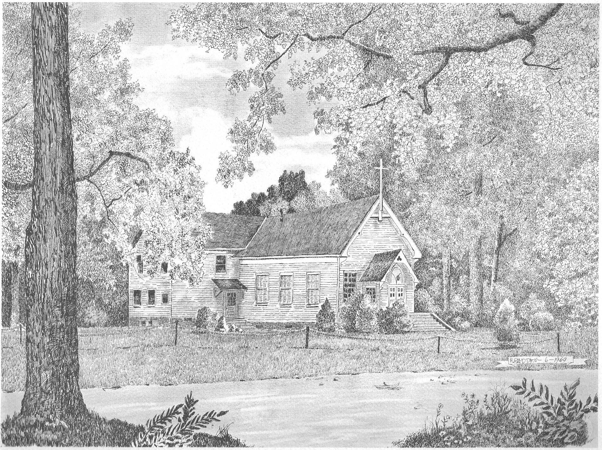

Silver Creek
Presbyterian Church
6 Old Rockmart Road
Silver Creek, GA 30173
706-234-6862
www.silvercreekpcusa.org

Rev. Camille Josey
Sunday January 22, 2023
Third Sunday After Epiphany

