WORSHIP
Tenth Sunday After Pentecost August 14, 2022

WELCOME and ANNOUNCEMENTS

Prelude

CALL TO WORSHIP
We are surrounded by a great cloud of witnesses.
Let us lay aside every weight and the sin that clings so closely.
Let us run with perseverance the race that is set before us.
Let us look to Jesus, the pioneer and perfecter of our faith and worship the Lord our God.

OPENING PRAYER (unison)
God of Peace, your call, at times, appears to divide us from one another. Help us to overcome our fears and respond in courage. Give us faith to trust the unity that is beyond our sight. Give us your eyes to recognize the signs before us. We ask this in the confidence of your Son, Jesus Christ our Lord. Amen.

*HYMN: The Church’s One Foundation. PH 442

CALL TO CONFESSION (liturgist)
Our sins and shortcomings are not permanent obstacles to God. Grace and forgiveness are freely given. Let us take this opportunity to humbly approach our God and confess our sins.

*PRAYER OF CONFESSION (unison)
Christ calls us to stand with the least and the last, but we cling to power and privilege. We fear worldly consequences for faithful action. We fail to follow where Christ leads, making excuses for ourselves, for our silence in the face of oppression, for our lack of action. Forgive us, God, and help us risk following where Christ calls. Amen.

*ASSURANCE OF PARDON (liturgist)
God’s love is sure and steadfast. Receive the good news that you are forgiven and return to right relationship with God. Amen.
In Jesus Christ we are forgiven!

*GLORIA PATRI Hymnal 579

CHILDRENS’ SERMON

PRAYER FOR ILLUMINATION (unison)
Open our ears and humble our hearts as we approach your Word read and proclaimed today, Great God. May we listen, discern and follow the path you intend for us. Amen.

FIRST READING: Jeremiah 23.23-29
SECOND READING: Luke 12:49-56

SERMON: The Division of Faith Rev. Camille Josey

*HYMN O Jesus, I Have Promised PH 388

JOYS AND CONCERNS

PRAYERS OF THE PEOPLE
THE LORD’S PRAYER: (unison)
Our Father, who art in heaven, hallowed be thy name. Thy kingdom come, thy will be done, on earth as it is in heaven. Give us this day our daily bread; and forgive us our debts as we forgive our debtors. Lead us not into temptation, but deliver us from evil, for thine is the kingdom, and the power, and the glory, forever and ever. Amen.

AFFIRMATION OF FAITH (unison) Barmen Declaration 8.11, 12, 14, 15,17
“Jesus Christ, as he is attested for us in Holy Scripture, is the one Word of God which we have to hear and which we have to trust and obey in life and in death…We reject the false doctrine, as though the church could and would have to acknowledge as a source of its proclamation, apart from and besides this one Word of God, still other events and powers, figures and truths, as God’s revelation…As Jesus Christ is God’s assurance of the forgiveness of all our sins, so in the same way and with the same seriousness is he also God’s mighty claim upon our whole life. Through him befalls us a joyful deliverance from the godless fetters of this world for a free, grateful service to his creatures…We reject the false doctrine, as though there were areas of our life in which we would not belong to Jesus Christ, but to other lords—areas in which we would not need justification and sanctification through him…The Christian Church is the congregation of the brethren in which Jesus Christ acts presently as the Lord in Word and Sacrament through the Holy Spirit. As the church of pardoned sinners, it has to testify in the midst of a sinful world, with its faith as with its obedience, with its message as with its order, that it is solely his property, and that it lives and wants to live solely from his comfort and from his direction in the expectation of his appearance. We reject the false doctrine, as though the church were permitted to abandon the form of its message and order to its own pleasure or to changes in prevailing ideological and political convictions.”

INVITATION TO GIVE

Special Music

*DOXOLOGY

*PRAYER OF DEDICATION

*HYMN Fight the Good Fight PH 307

*BENEDICTION

*AMEN (sung)

Postlude

August 7, 2022 Attendance in person: 13 Virtual: 50
Offering (General): $ 1057.00
Offering (designated): 0.00
Offering (Total): $ 1057.00
Average General Giving per Week $ 1104.00

Giving YTD: $37,575.82
Designated: 2,247.82
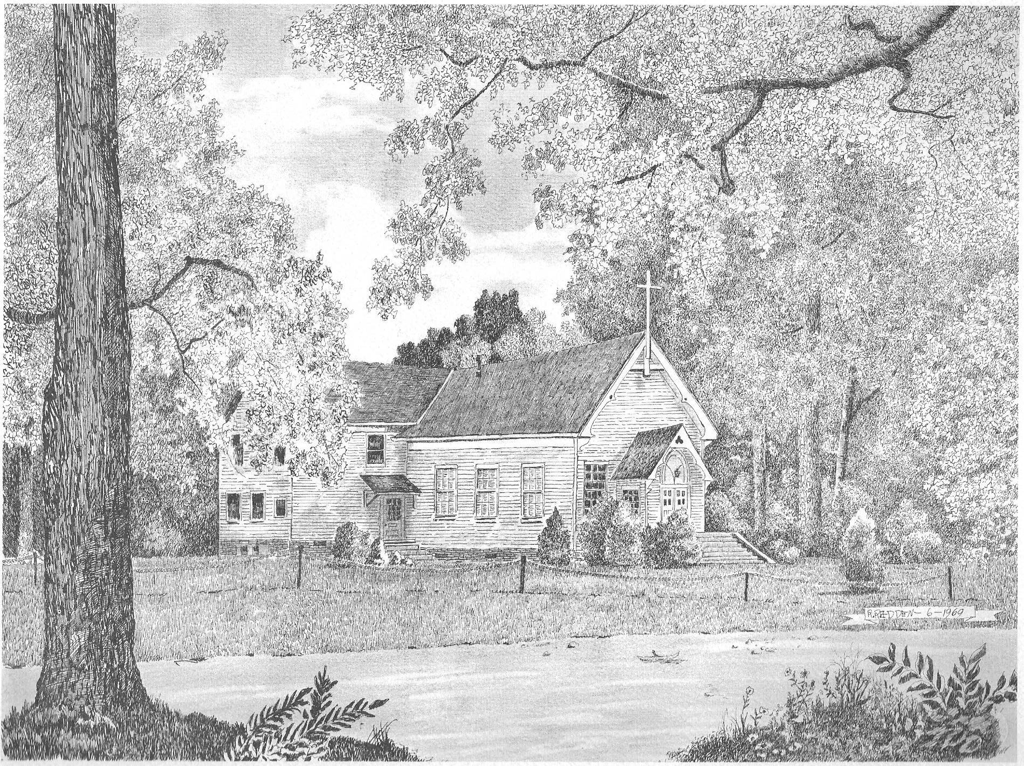

Silver Creek
Presbyterian Church
6 Old Rockmart Road
Silver Creek, GA 30173
706-234-6862
www.silvercreekpcusa.org

Rev. Camille Josey
Ninth Sunday After Pentecost August 14, 2022

