**WORSHIP**

**17th Sunday after Pentecost**

**September 24, 2023**

WELCOME and ANNOUNCEMENTS

PRELUDE AND LIGHTING OF CANDLES

CALL TO WORSHIP

We will sing to God

and bless God’s name forever and ever.

**Great is the Lord, and greatly to be praised!**

We will declare God’s mighty acts

and celebrate God’s abundant goodness.

**Let us worship, singing of God’s righteousness.**

Sung Response (see insert)

OPENING PRAYER

**God, our source and our salvation, in love you made us and by love you have redeemed us. Make your love for us bear fruit in our forgiveness of others, that in this life we may know your all-embracing compassion and in the world to come receive the everlasting joy of fellowship you share with your Son, Jesus Christ, and the Holy Spirit. Amen.**

*HYMN: *There’s a Sweet, Sweet Spirit in This Place* Hymnal 398

CALL TO CONFESSION (liturgist)

﻿We try to live our lives in a manner worthy of Christ. We try to

stand firm in God’s spirit, but our human self-interest gets the

better of us. In humility and faith, let us confess.

*PRAYER OF CONFESSION (unison)

**﻿God of generosity, we find ourselves bitter when faced with**

**your abundant grace. We believe ourselves more deserving**

**than others. We nurse our anger and resentment at those**

**you forgive, instead of rejoicing in the abundant love you**

**show. Forgive us when we wish your grace was scarce.**

**Forgive the double standards we hold. Help us to know that**

**we are all in need of your grace, and help us rejoice as we**

**all gratefully receive your mercy.**

DECLARATION OF FORGIVENESS

The grace of God is boundless, poured out freely for all of us.

**We will receive this gift of forgiveness, and trust God to transform our lives!**

*GLORIA PATRI. Hymnal 578

CHILDREN’S SERMON

PRAYER FOR ILLUMINATION

**Faithful God, how blessed are those who hunger and thirst for righteousness.Sanctify us by your Word and Spirit so that we may glorify you in the company of the faithful; through Jesus Christ our Lord. Amen.**

SCRIPTURE READING(S): Exodus 16.2-15

Matthew 20.1-16

SERMON Rev. Camille Josey

*HYMN: *Come Thou Fount of Every Blessing Insert*

AFFIRMATION OF FAITH *from A Brief Statement of Faith*

**We trust in God the Holy Spirit, everywhere the giver and renewer of life. The Spirit justifies us by grace through faith,**

**sets us free to accept ourselves and to love God and neighbor, and binds us together with all believers in the one body of Christ, the Church. In a broken and fearful world the Spirit gives us courage to pray without ceasing, to witness among all peoples to Christ as Lord and Savior, to unmask idolatries in Church and culture, to hear the voices of peoples long silenced,**

**and to work with others for justice, freedom, and peace. In gratitude to God, empowered by the Spirit, we strive to serve Christ in our daily tasks and to live holy and joyful lives, even as we watch for God’s new heaven and new earth, praying, “Come, Lord Jesus!” With believers in every time and place, we rejoice that nothing in life or in death can separate us from the love of God in Christ Jesus our Lord.**

JOYS AND CONCERNS

PRAYERS OF THE PEOPLE

INVITATION TO GIVE

Special Music

*DOXOLOGY Hymnal 592

*PRAYER OF DEDICATION

JOYS AND CONCERNS

*HYMN: *Guide Me O Thou Great Jehovah* Hymnal 281

*BENEDICTION

*AMEN (sung)

Postlude

Sept 17, 2023: Attendance in person: 17. Virtual 63. Offering (General) $1,360.00

Offering (Designated) 150.00

Offering (Total): $1,510.00

Offering (Total YTD): $44,129.93

Offering (Designated YTD) $. 2,326.19

Average General Giving per Week $ 1,161.31

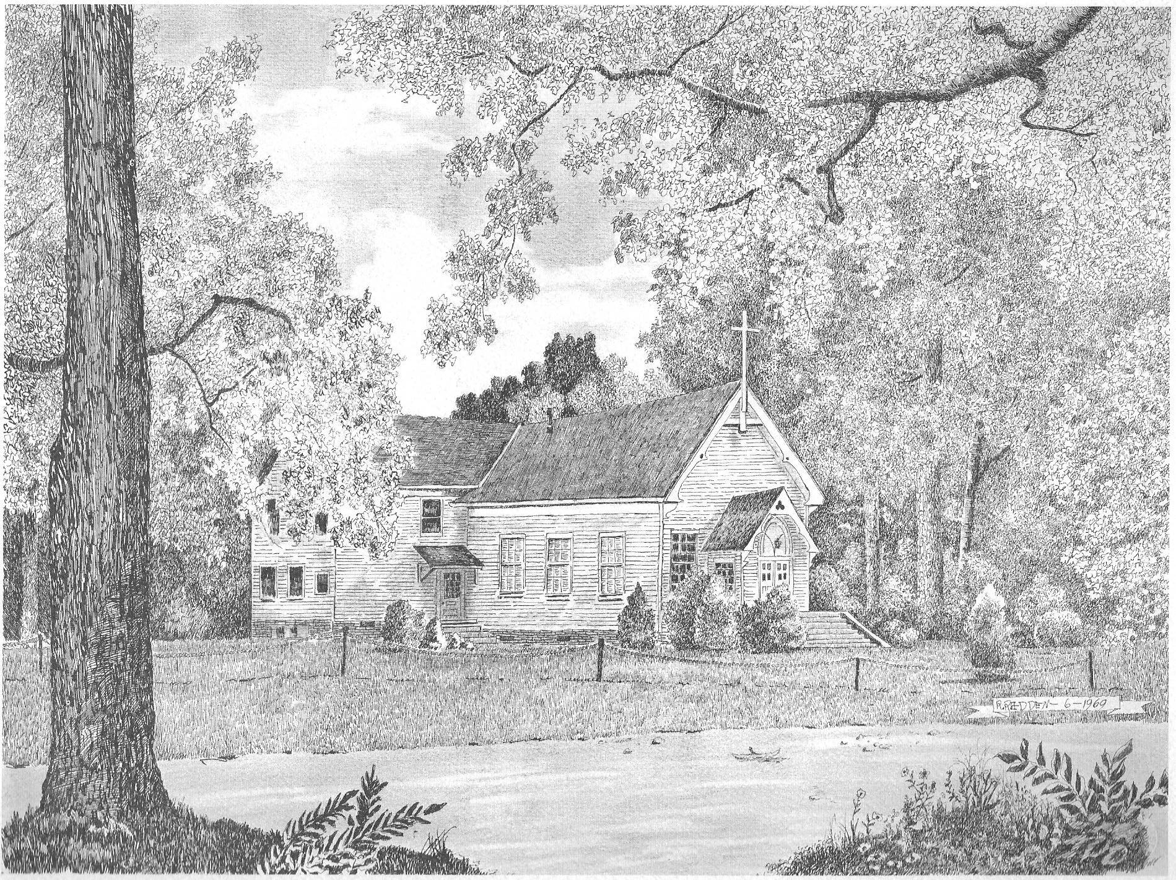

**Silver Creek**

**Presbyterian Church**

**6 Old Rockmart Road**

**Silver Creek, GA 30173**

**706-234-6862**

[**www.silvercreekpcusa.org**](http://www.silvercreekpcusa.org/)

**Rev. Camille Josey**

**Sunday September 24, 2023**

**Seventeenth Sunday after Pentecost**

